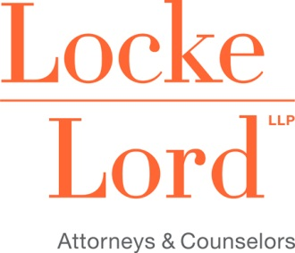

Attendance Verification Form
(CLE)
I, _________________________________, acknowledge receipt of the course materials for:
(participant name)
OSHA & COVID-19: What Should Employers Know and Do?
(Course Title
__________________________________________________________________
(Date of completion)
I certify that I have participated in the above course in its entirety. Therefore, I request that I be
awarded the applicable number of _____ CLE credits for this course.
The verification code announced during the Webinar is:
Code 1: ___________

I am seeking CLE credit in (state)____________, in the amount of _________ credits.

CLE credit for this program has been awarded in the following states CA, IL, TX – .50; NY – .50 (Areas of Professional Practice); RI – (pending).

____________________________________________ ______________________________
Print Name Bar Number
______________________________________________________________________________
Signature of Participant
______________________________________________________________________________
E-mail Address
To obtain CLE credit, please complete and sign this form and then submit it to Debbie S. Bain by email at dbain@lockelord.com or fax at 213-341-6740.
In IL, TX and RI your CLE credit will be reported to the State Bars and your Certificate of Attendance will be emailed to you.

