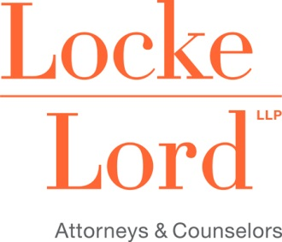

Attendance Verification Form
(CLE)
I, _________________________________, acknowledge receipt of the course materials for:
(participant name)
How to Survive a DOJ Investigation
(Course Title)
__________________________________________________________________
(Date of completion)
I certify that I have participated in the above course in its entirety. Therefore, I request that I be
awarded the applicable number of _____ CLE credits for this course.
The verification codes announced during the Webinar are:
Code 1: ___________ Code 2: ___________‎

I am seeking CLE credit in (state)___________, in the amount of _________ credits.

CLE credit for this program has been awarded in the following states CA, IL, TX- 1.0; NY – 1.0 (Areas of Professional Practice).

____________________________________________ ______________________________
Print Name Bar Number
______________________________________________________________________________
Signature of Participant
______________________________________________________________________________
E-mail Address
To obtain CLE credit, please complete and sign this form and then submit it to Debbie S. Bain by email at dbain@lockelord.com or fax at 213-341-6740.
In IL & TX your CLE credit will be reported to the State Bar and your Certificate of Attendance will be emailed to you. CA & NY – participants will receive a Certificate of Attendance.

